**MaterialRouter**

**https://github.com/Madevil/MaterialRouter/releases**

Function:

1.Make a material_clone(now replaced by copy material in ME3)

2.Seperate material of clothes if it has clothing and shifting.

Example:

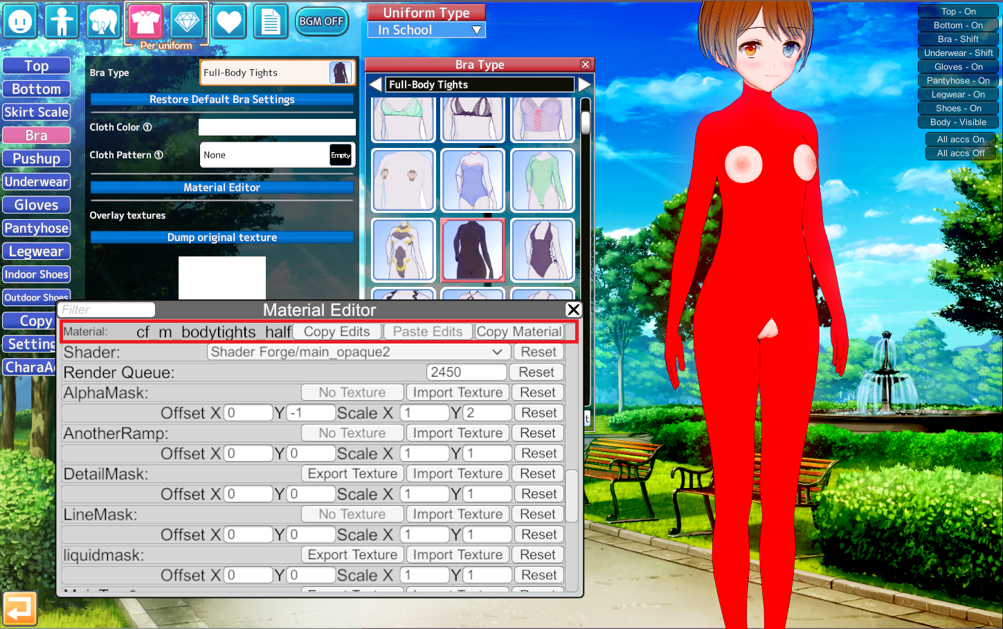

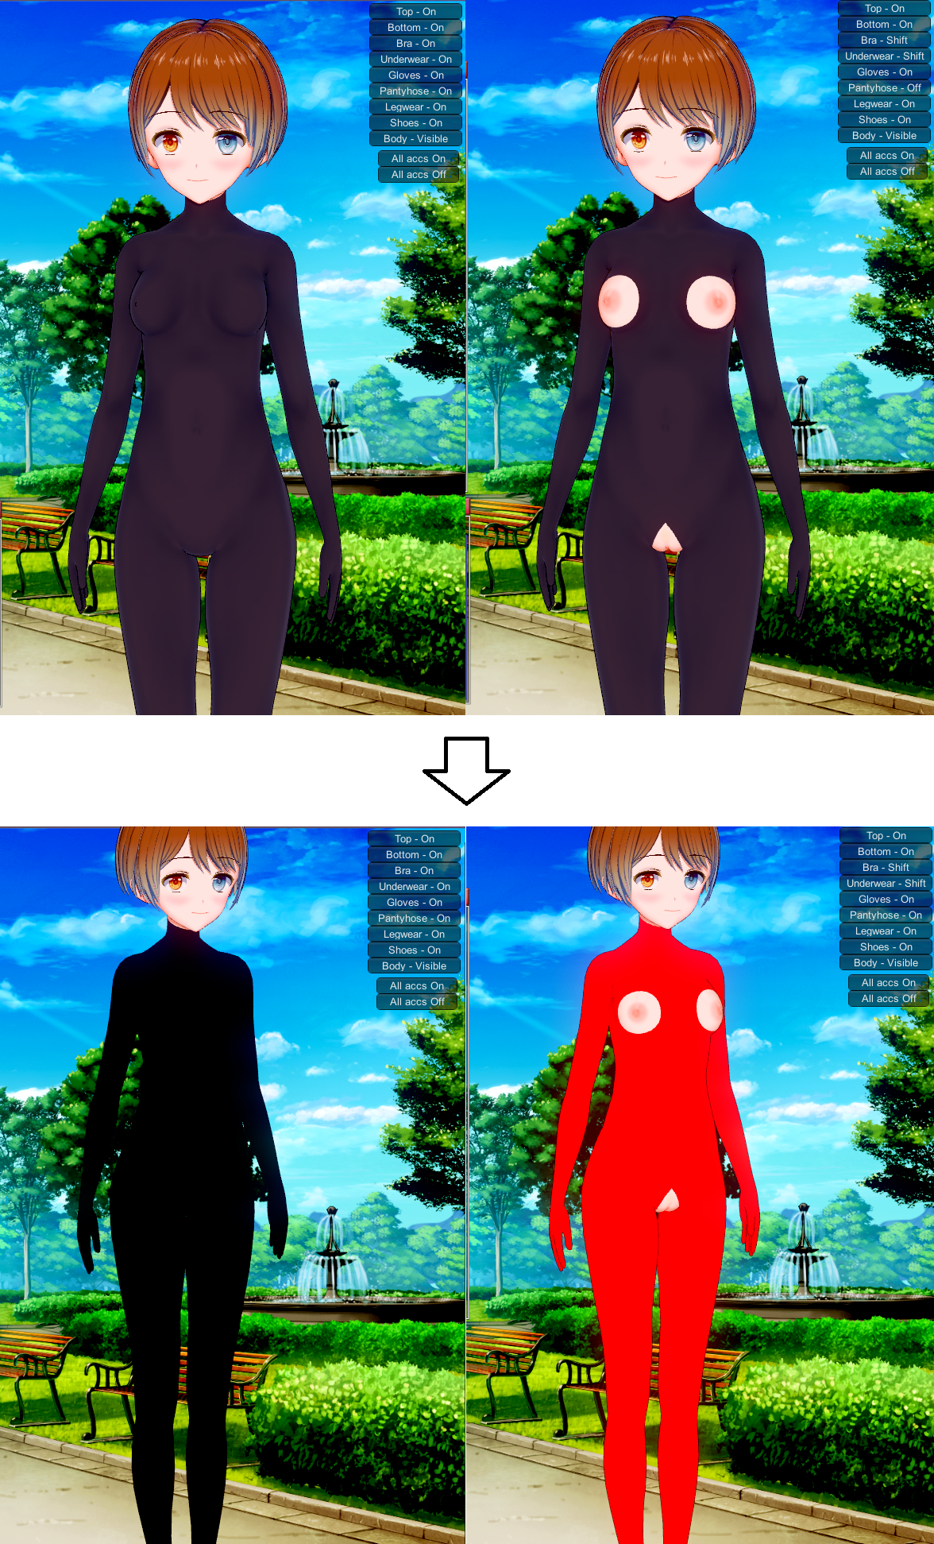

HOW

Install:

Put MaterialRouter.dll in BepInEx\plugins in your game folder.

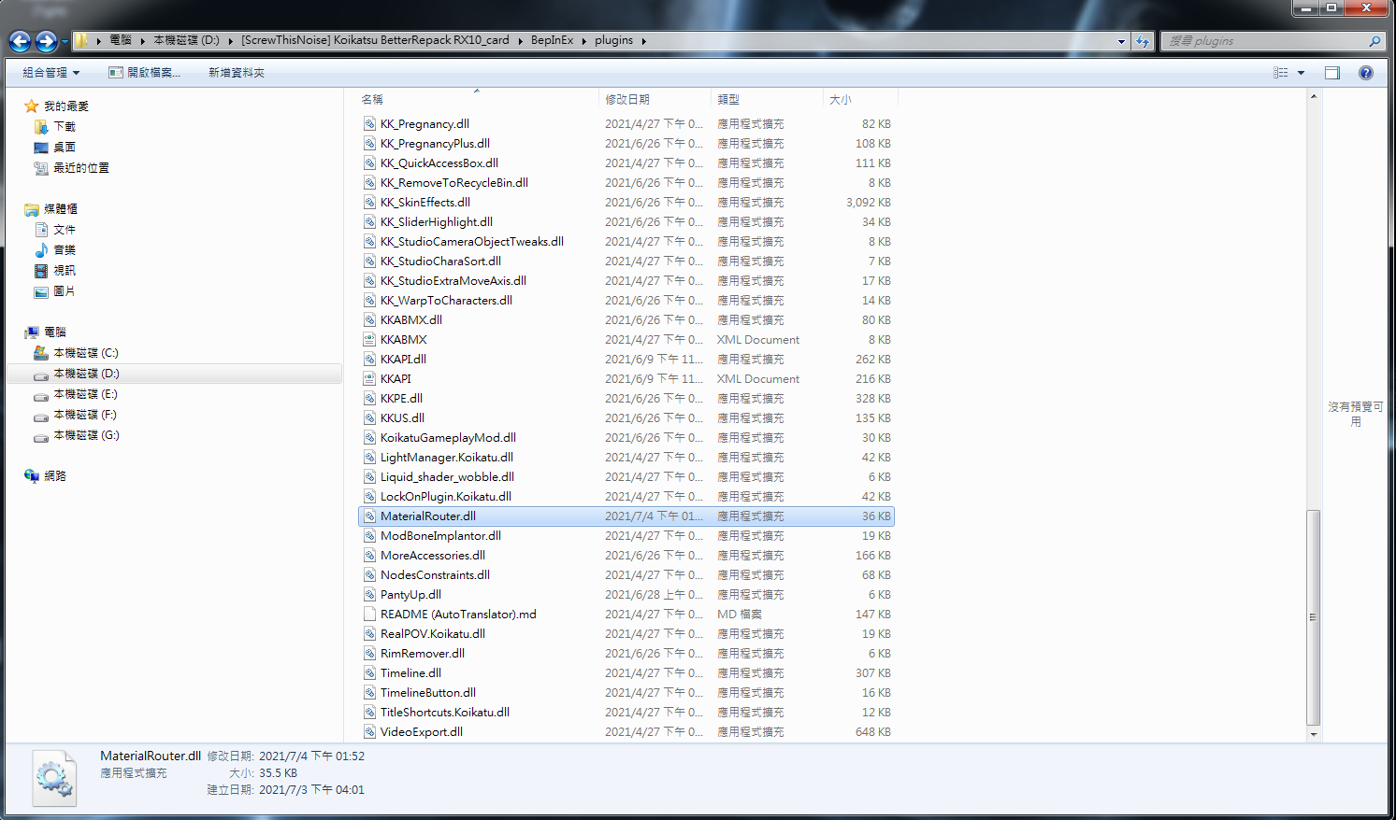

Open game with **Activate Console**

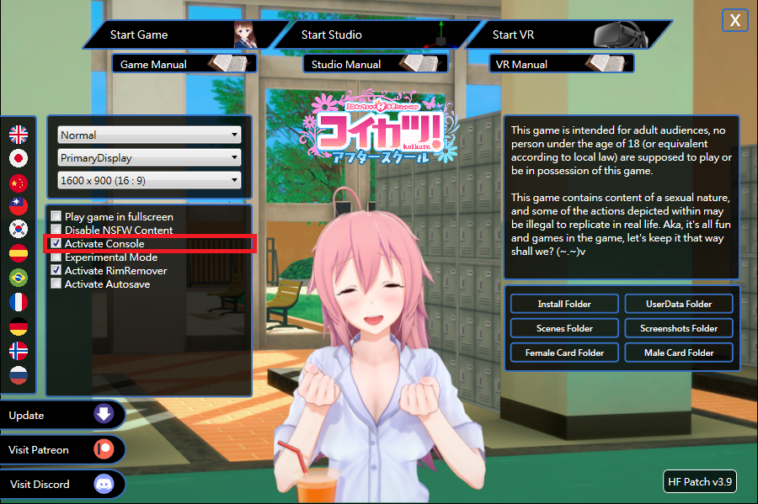

In Game, you will find a new function named Router added.

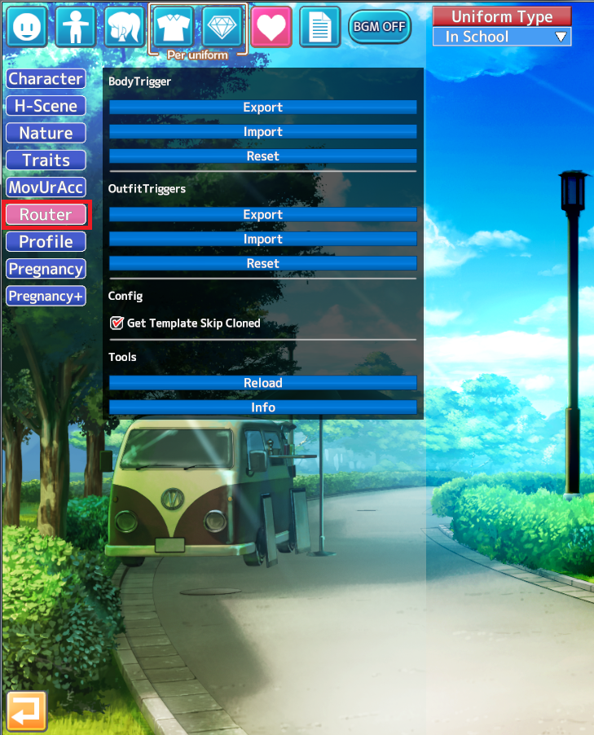

To the clothes menu, Full-body Tights for example. Press **Console Output**

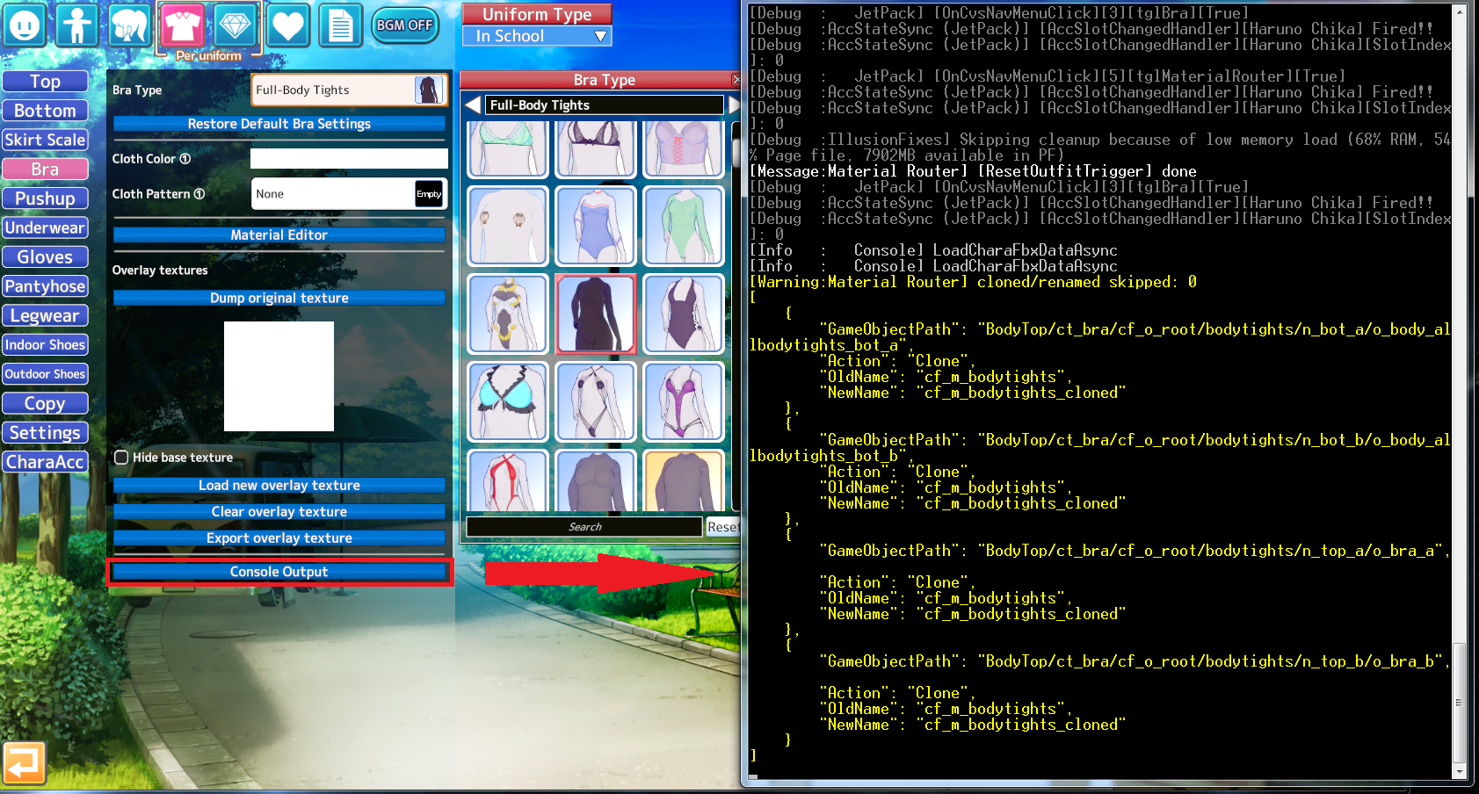

Open **MaterialRouterOutfit with JSON Editor.**

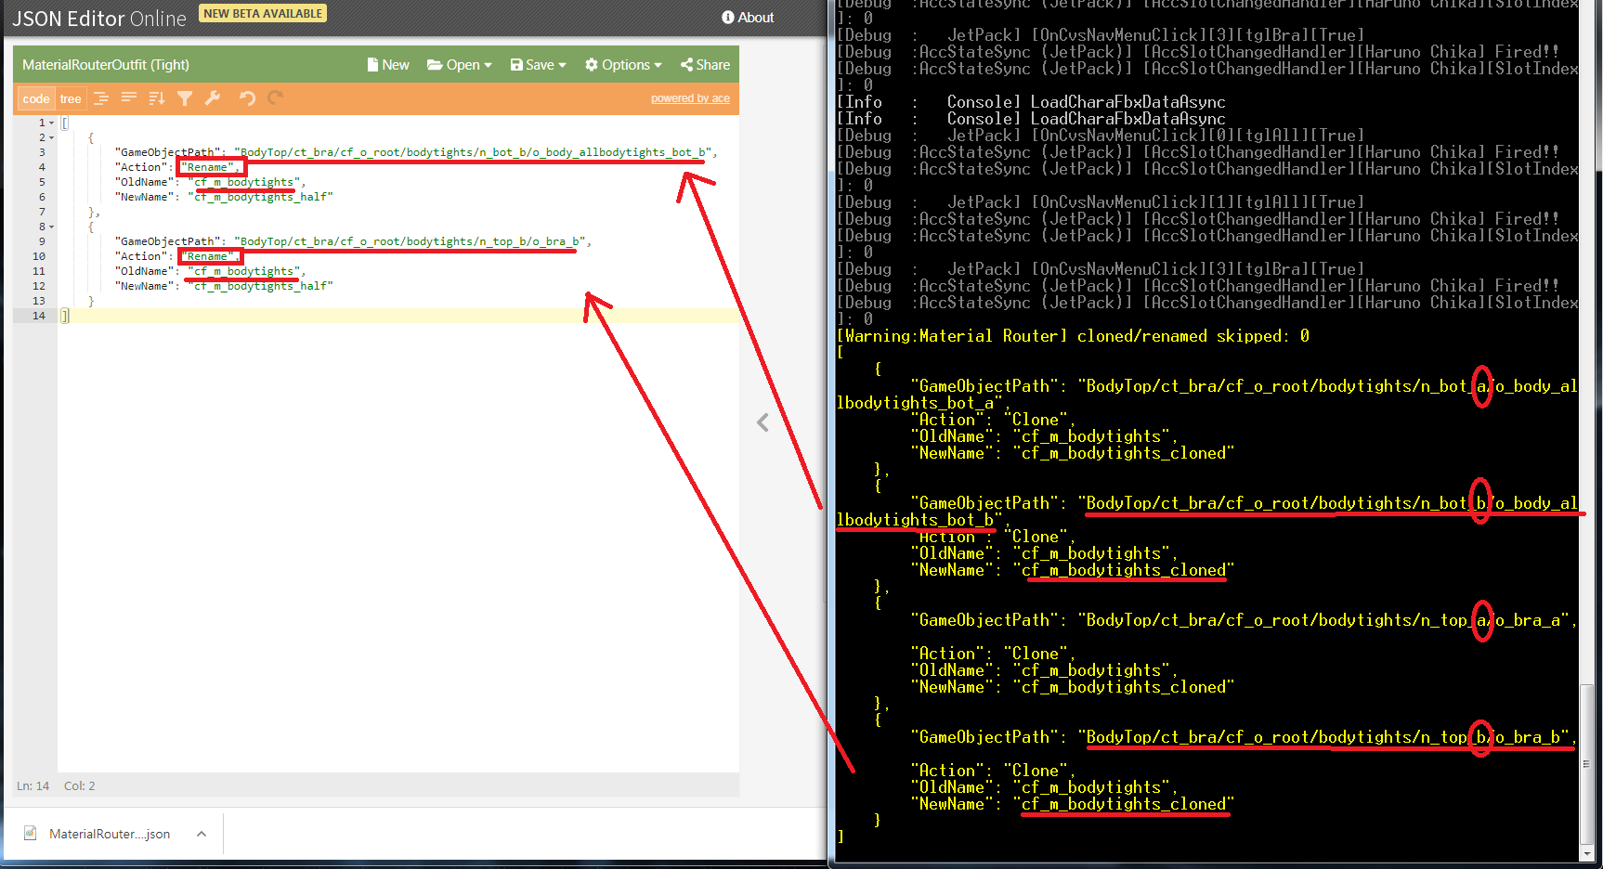

Recognize which GameObject is shifted_clothes. (Mainly **b** or **half** in Path or file name)

Copy the path and object names into the json file.

The “Oldname” should be as same as the object name in console.

Change the “Newname” to a different name.

The “Action” should be “Rename”

Then save it and put it into the “Temp” folder in your game folder (You can create one if you don’t have one.)

Make sure the json file still named”MaterialRouterOutfit”

Import it by Router in game

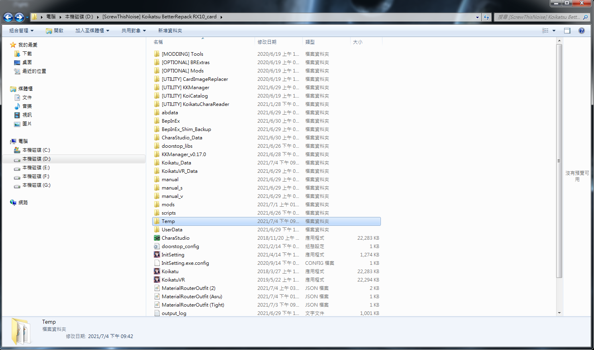

Change suit to make MEloader reload the clothes.

You will find new material in ME.

